Problem-Definition:
Manual examination system is hard to maintain. It needs a lots of time to conduct the exam and it needs pen and paper that is also very difficult make correction. Furthermore , it is not user friendly and accurate. For this reason to solve this manual problem we are planning for online examination system . The Purpose of the Online examination system are:

- The purpose of online test simulator is to take test in an efficient
manner and no time wasting for checking the paper.

- It saves time as it allows number of students to give the exam at a
time and displays the results as the test gets over, so no need to
wait for the result.

- The main objective of online test simulator is to efficiently
Evaluate the candidate thoroughly through a fully automated
System that not only saves lot of time but also gives fast results.

- This can be used in educational institutions as well as in corporate

- This can be used anywhere any time as it is a web based application
(user location doesn’t matter).

- Secure

- Easy to use

- Reliable and accurate

Requirement Gathering:

Interviewing the layman:

>Making appropriate checklist and following it.

>Ask question regarding what they expect more from online
examination system.

Interviewing the Project Mentor:

>What technology we can use and how we can proceed .

>What future enhancement he is looking for.

Analyzing the present website:

>www.4tests.com: We have searched every page of freshers.com
And analyzed it .From this we have learned a lot of valuable
information.

>www.testfunda.com: It deals with a lot of ideas that helps us to
continue this project.

Analysis:

We have analyzed that Manual examination system have a lot problems such as

- It is hard to maintain.
- It is time wasting procedure.
- Not accurate.
- Not user friendly.
- Not secure.

So we have tried to solve this problem through Online examination system.
We wanted to complete our examination system in an efficient manner and no time wasting for checking the paper.

Here we will be using a fully automated system that will generate result correctly
And efficient way within a fraction of time and it is accurate. Hence , it save a lot of time .

We will be making such a system that will be able use both educational institutions as well as in corporate. And it is secure, reliable and easy to use.

- FUNCTIONAL REQUIREMENT

R1: Login

Description : The login function asks the user to enter his username and password and grants entry to either user/admin by checking whether the username and password are correct or not .

R1.1:Select login option
Input: “login “option.
Output: user prompted to enter the username and password.
R1.2: Enter username and password
Input: Username and password.
Output: Student/Admin page is displayed .
Processing: If username and password are correct then login as
Admin /student else back to the prompt to enter username and password.
R2: Register student

Description : Once the admin selects the registration option then the
admin enters the data entered the paper form submitted by the student .If form is filled correctly the registration is successful and system generated password is given to the user .

R2.1: Select register option
Input: “Register” option.
Output: admin prompted to enter registration details with the
help of paper form filled by student.

R2.2:Enter registration details
Input: Registration form.
Output: Student is registered and is given a unique
password.
Processing: If form is filled correctly give the password else
error message is displayed.

R3: Take sample test

Description :When the user selects the sample test option the user is allowed to take a sample test in order to get a hang of the system .

R3.1:Select sample test option
Input: ”Sample test” option.
Output: User is allowed to answer a sample test.

R3.2:Finish test

Input: ”Finish test” option.
Output: Score is displayed on the screen.

R4:Take exam
Description :When the user selects the exam option the user is prompted to enter the Exam password ( to be disclosed just before the exam at the exam centre) .Once the user enters the correct password he can start the exam .The exam consists of three levels and the user has to get passing marks in each level in order to go on to the next level .Once the final level is passed the result of his exam his displayed automatically .

R4.1:Select take exam option
State: The student has already logged in and student page is
displayed.
Input: ”Start exam” option.
Output: student prompted to enter exam password .

R4.2: Enter Exam Password
Input: exam password.
Output: First level of questions appear .

R4.3: Finish level 1
Input: “finish level1” option.
Output: Second level of questions appear .
Processing: If student secure more than 50% then level 2 question
will appear else failed.

R4.4: Finish level 2
Input: ”finish level 2” option.
Output: Third level of questions appear .
Processing: If student secure more than 50% then
level 3 question will appear else failed.

R4.5: Finish level 3
Input: ”finish level 3” option.
Output: Automated final exam result will display.
Processing: If student secure more than 50% then passed else
failed

R5: Generate reports
Description : When the admin selects the "Generate Reports" option the results are shown according to the date entered and the subject of the exam .The admin also has the option to print out the results .

R5.1: Select report generation option
State: Admin has already logged in and admin page is
displayed.
Input: “Generate reports ” option.
Output: user prompted to enter either select date or subject.

R5.2: View result
Input: Date/subject.
Output: List of results of exam on that date / subject and
user is given to option to print.

R5.3: Print results
Input: ”Print” option.
Output: Results are printed out.

R6: Upload question
Description :When the admin selects the "Upload Question "option then the admin is prompted to enter subject and level of questions to be uploaded . A web interface appears to enter questions , options and correct answer .

R6.1: Select uploaded question option
Input: “Upload question” option.
Output: User prompted to enter subject and level.

R6. 2: Enter subject and level of question
Input: Subject and level.
Output: Web interface appears to enter question one by one.

R6.3: Enter question
Input: Question, options and correct answer entered.
Output: Prompt to enter next question.

R6.4: Select submit button
Input: “Submit ” option selected.
Output: Question upload page.

R7 Edit/View question
Description :When the admin selects the "Edit/View Question “ option
then the admin is prompted to enter subject ,level , teacher .The questions are displayed which satisfy the constraints with a edit option .The admin has the
option to edit and save the questions .A question can also be deleted .

R7.1: Select edit/view question option
Input: “edit/View question” option.
Output: Admin is prompted to enter subject, level and
teacher.

R7. 2: Enter subject, level, teacher
Input: Subject, level, teacher.
Output: Display questions which satisfy the constraints one by
one.

R7.3: Select next option
Input: ”Next” option.
Output: Next question is displayed.

R7.4: Select edit option
Input: “Edit option”.
Output: Same question is displayed after updation (editing).

R7.5: Select delete option
Input: “Delete ” option.
Output: Next question is displayed after preview question is
deleted from database.

R8: view Account
Description :When the admin selects the "View Account" option then
the list of the Accounts are displayed .You can also select any account to get detailed information of user .

R8.1: Select view account option
Input: “view account” option.
Output: List of accounts are displayed.

R8.2: Select filter by subject option
Input: “Subject” selected.
Output: Filtered list of accounts are displayed.

R8.3: Select particular account
Input: Account selected.
Output: All student details are displayed.

R9: Set exam
Description : When the admin selects the "Set Exam " option then the
admin is prompted to enter the subject ,duration and date .A exam password is generated when the set .

R9.1 Select set exam option
Input: ”set exam” option.
Output: User is prompted to enter subject, duration and date.

R9.2: Enter subject and date
Input: Subject and date.
Output: Exam password generated.

ii. NON-FUNCTIONAL REQUIREMENT

1.System should be secure.

2.Speed of access of questions should be fast.

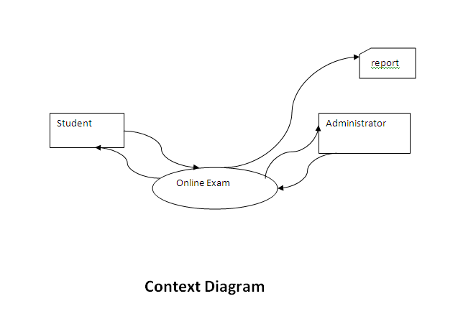

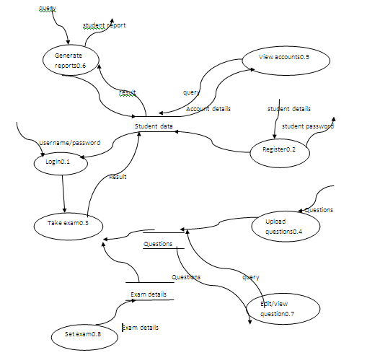

Level-1DFD

UML-DIAGRAM:

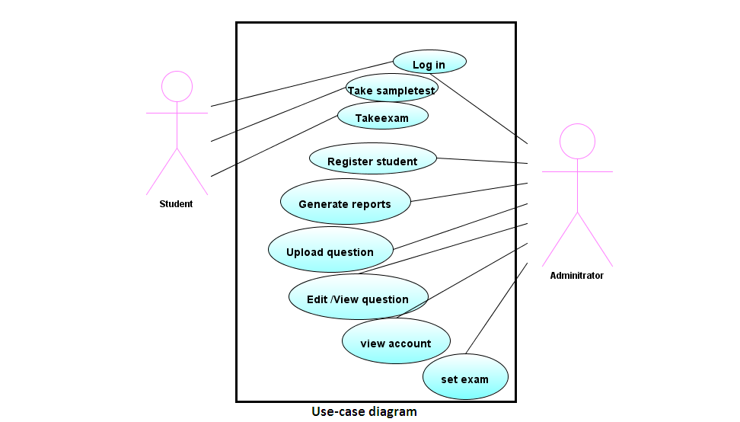

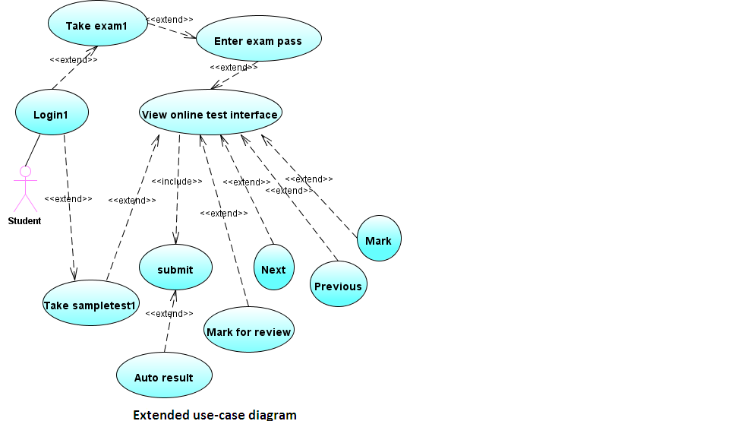

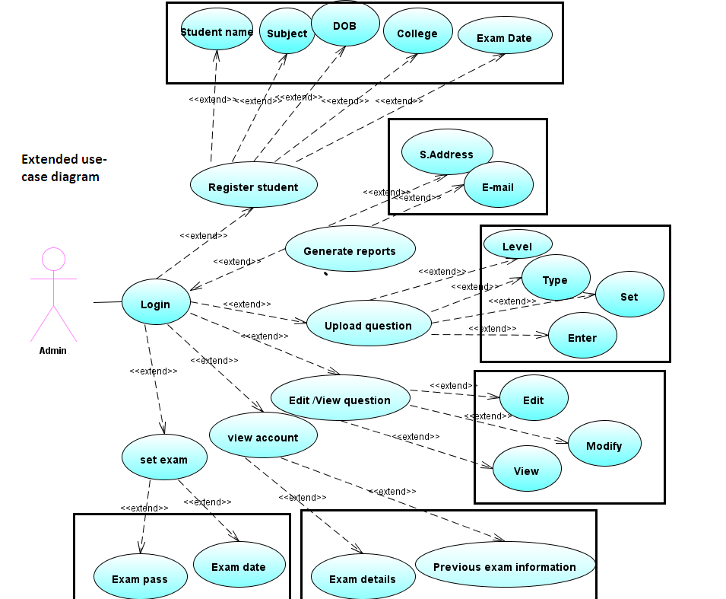

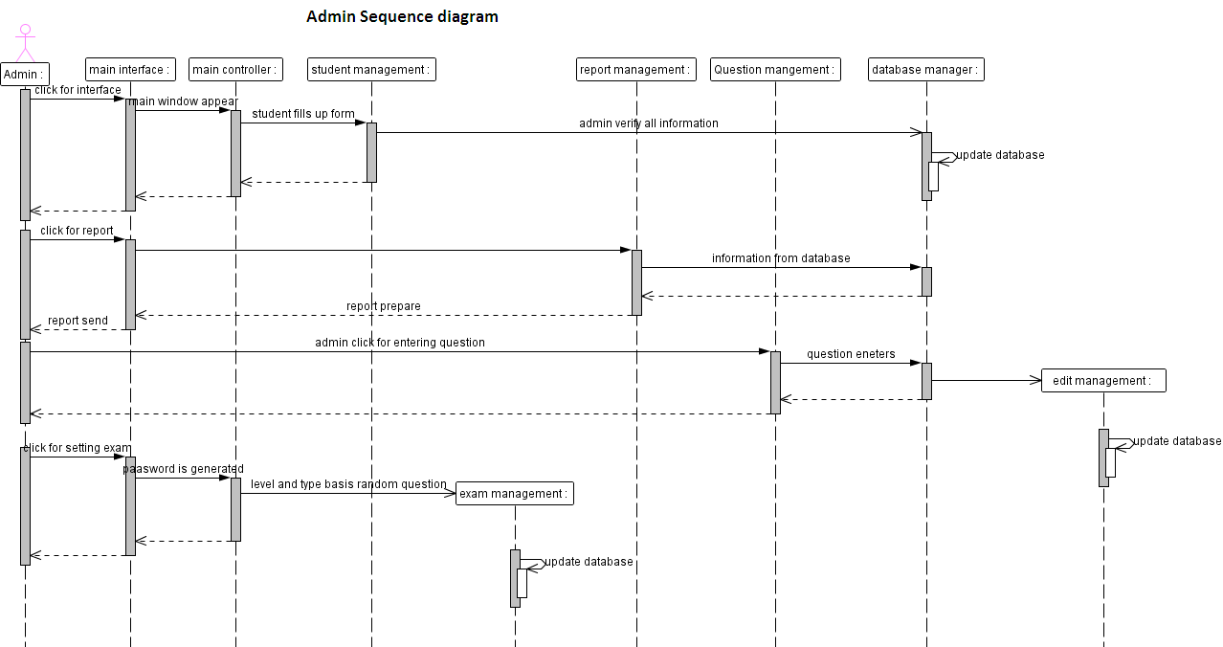

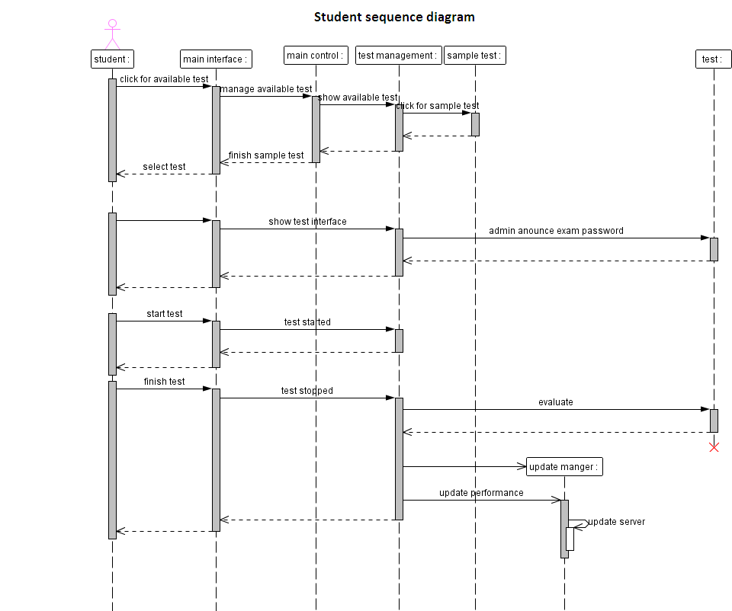

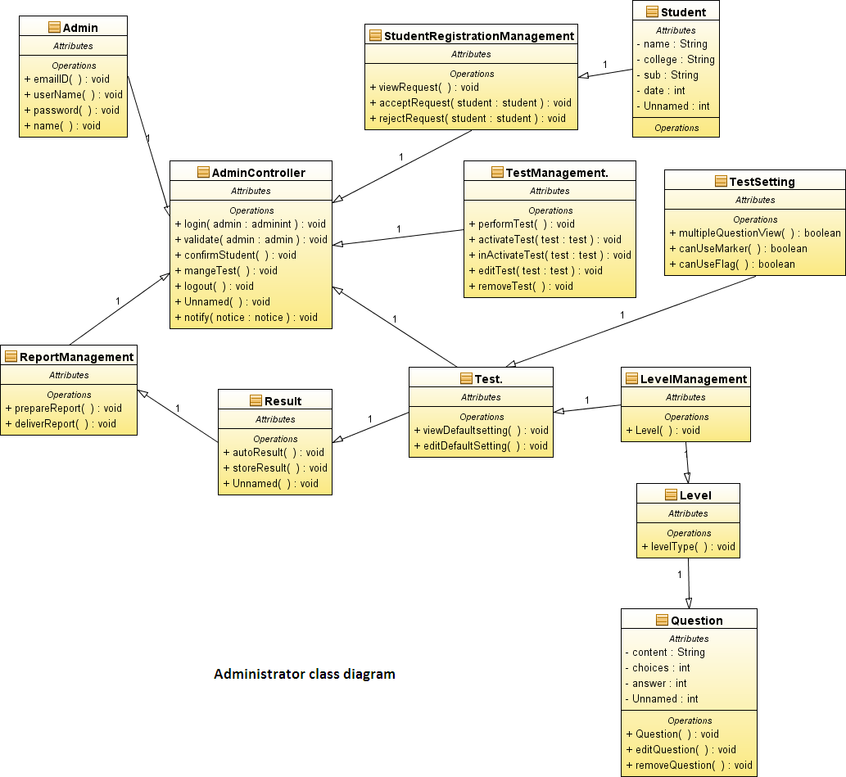

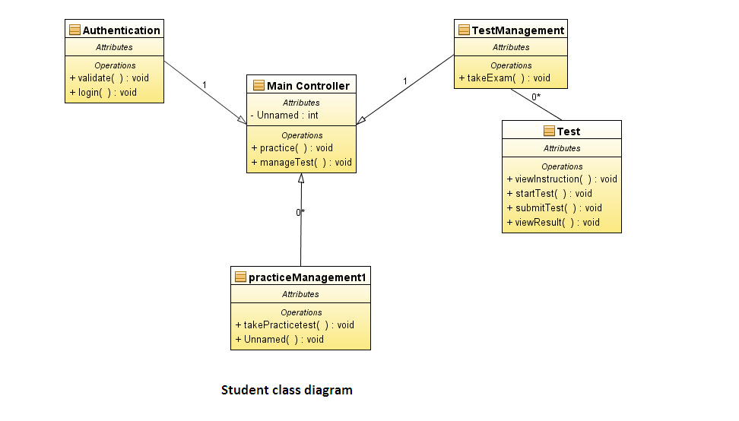

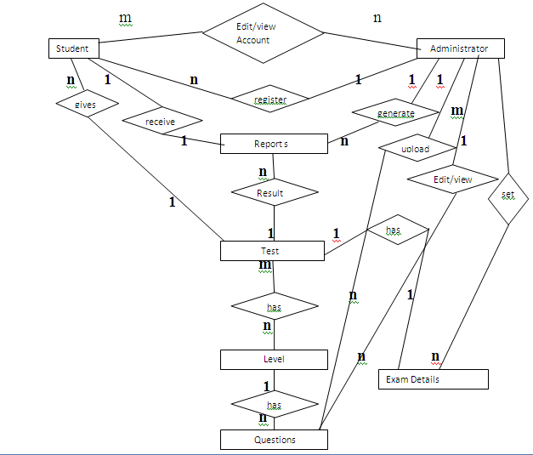

E-R DIAGRAM

Table:

- Student
- Student_id(pk)
- Test_id(fk)
- Admin_id(fk)
(2)Questions
- Quesid(pk)
- Leveled(fk)
- Admin_id(fk)
(3)Levels
- Leveled(pk)
(4)Test_levels
- Testid(fk)
- Leveleid(fk)
(5)Admin_edit_questions
- Quesid(fk)
- Admin_id(fk)
(6)Test_has_examdetails
- Testid(fk)
- Examdeatils_id(pk)
(7)Examdetails
- Examdeatils_id(pk)
- Admin_id(fk)

(8)Test
- Testid(pk)
(9)Reports
- Reportid(pk)
- Testid(fk)
- Admin_id(fk)
- Student_id(fk)

(10)Student_admin
- Student_id(fk)
- Admin_id(fk)

(11)Admin
- Admin_id(pk)

SNAPSHOTS:

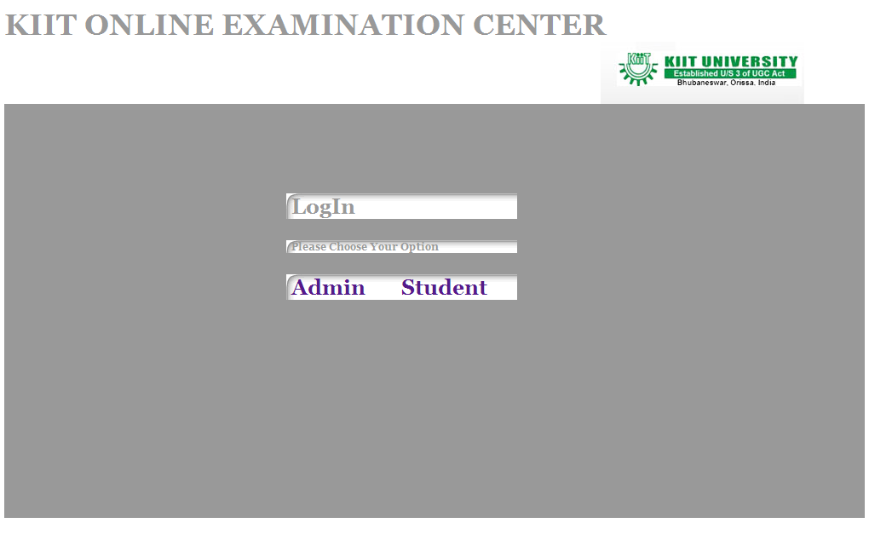

Fig: Exam Welcome Page

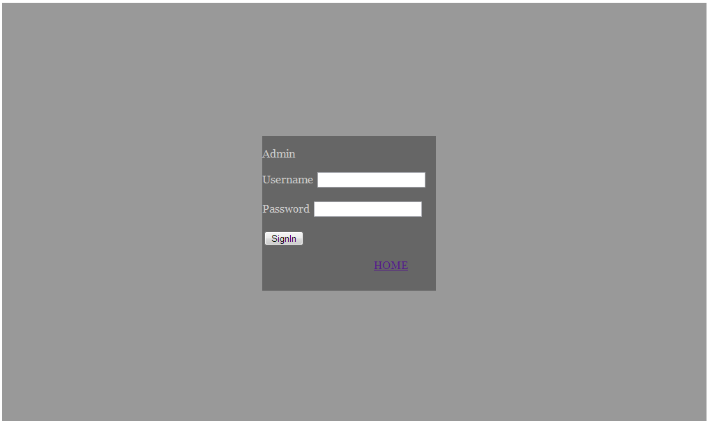

Fig: Admin LogIn Page

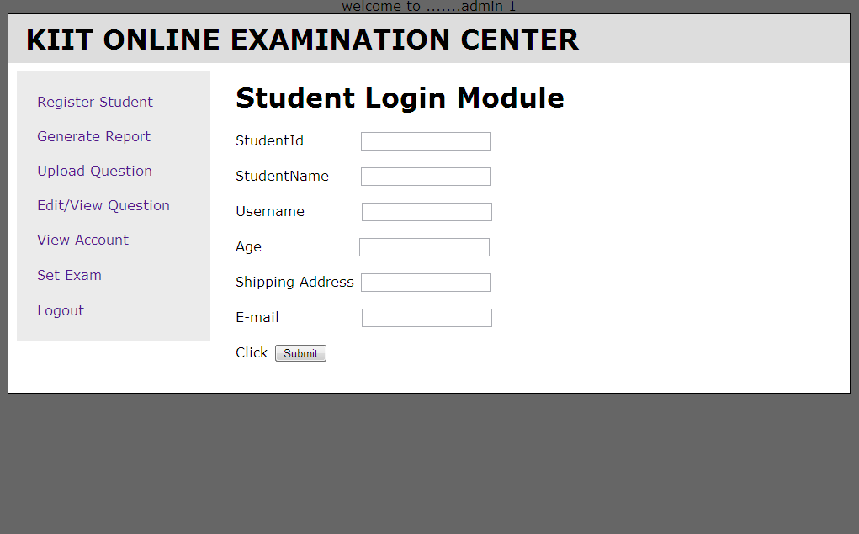

Fig: Register Student Page

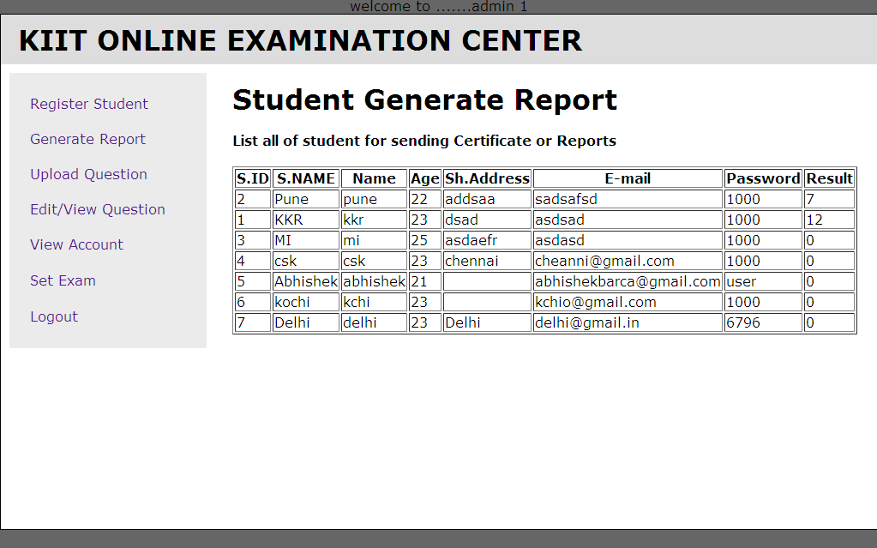

Fig: Student Generate Report Page

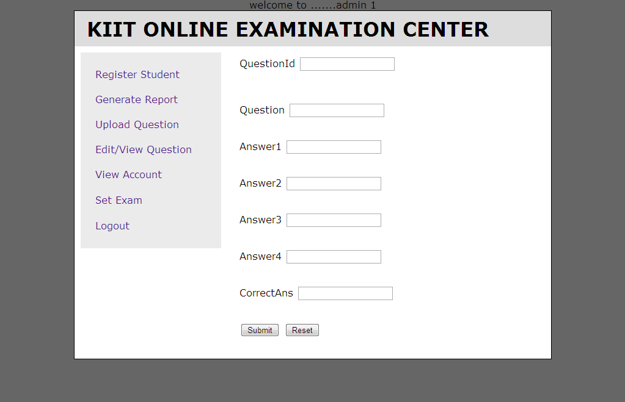

Fig: Upload Question Page

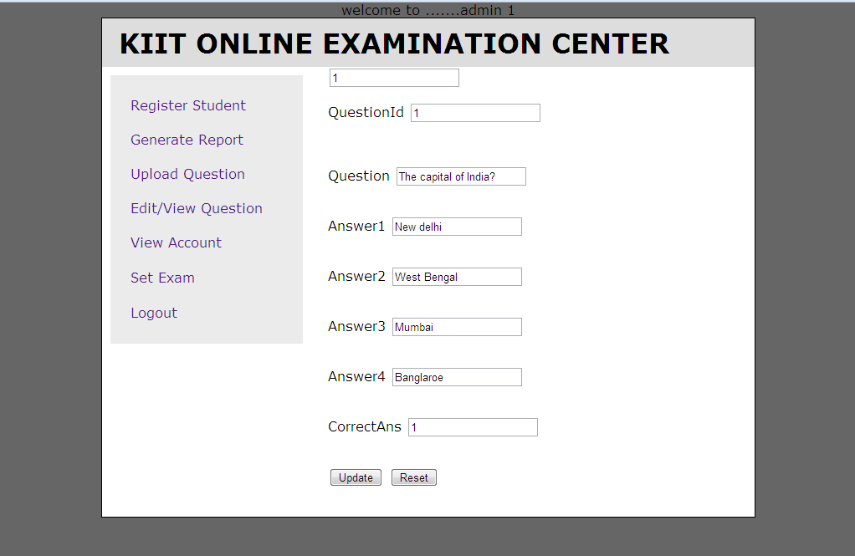

Fig: Edit/View Question Page

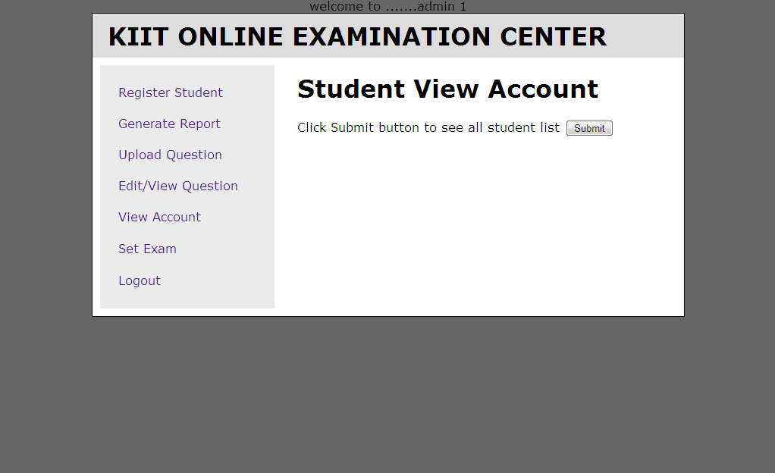

Fig: View Account Page

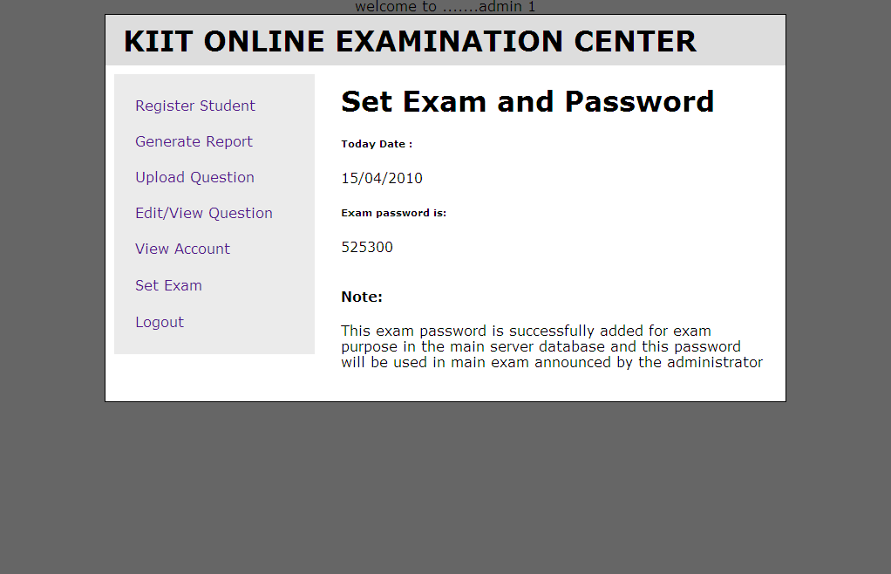

Fig: Set Exam Page

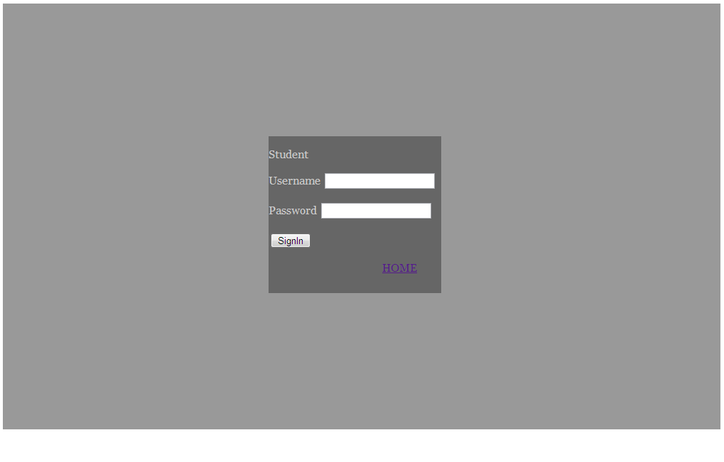
Fig: Student LogIn Page

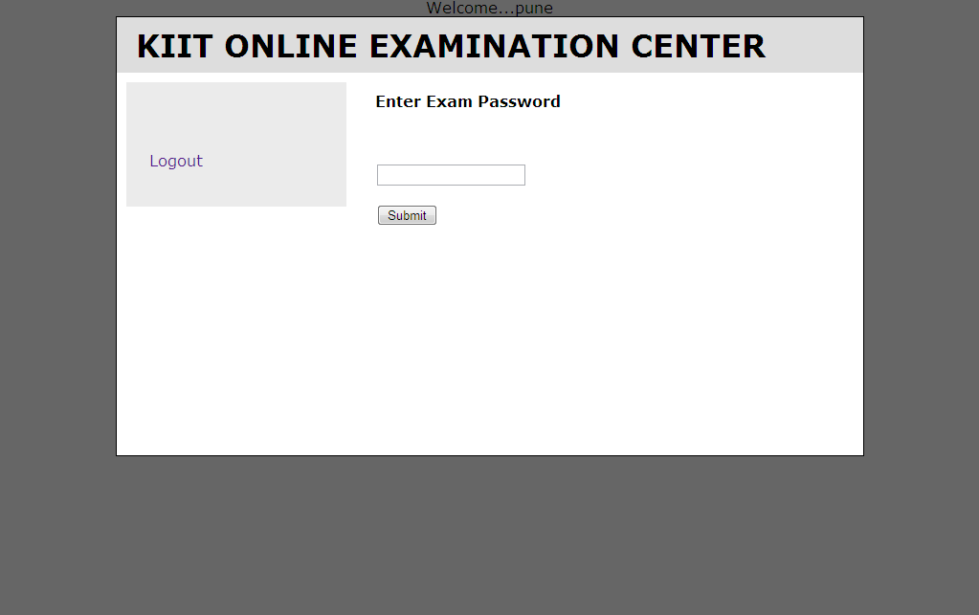

Fig: Enter Exam Password Page

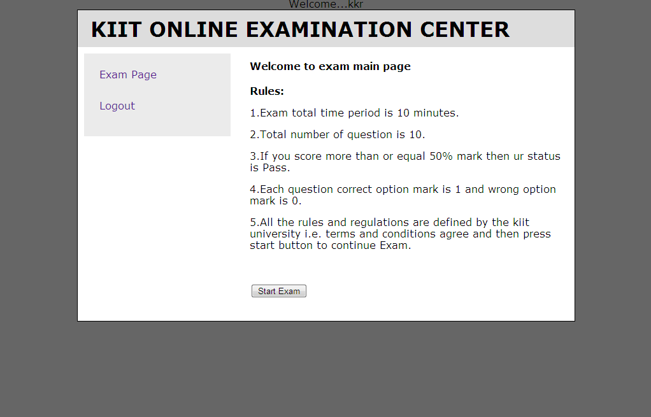

Fig: Student Welcome Page

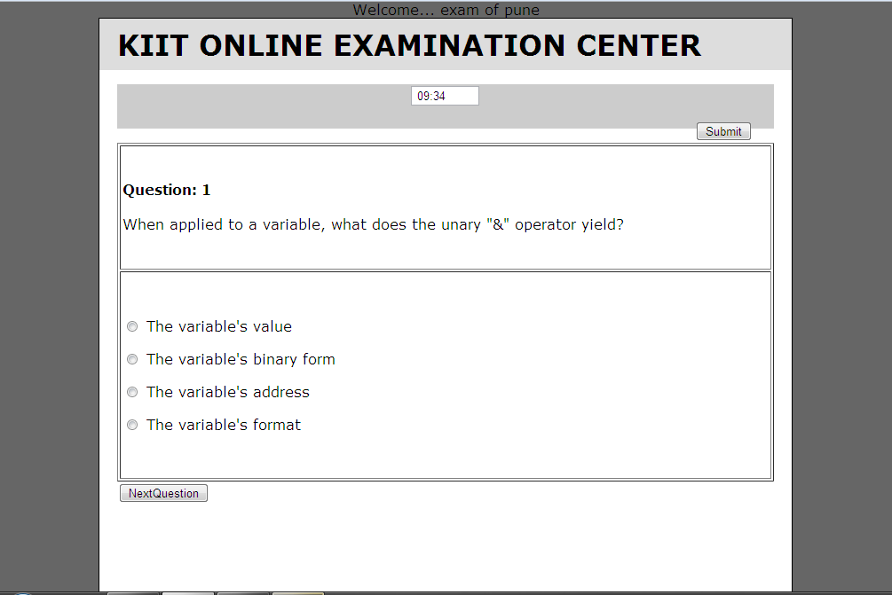

Fig: Exam Page

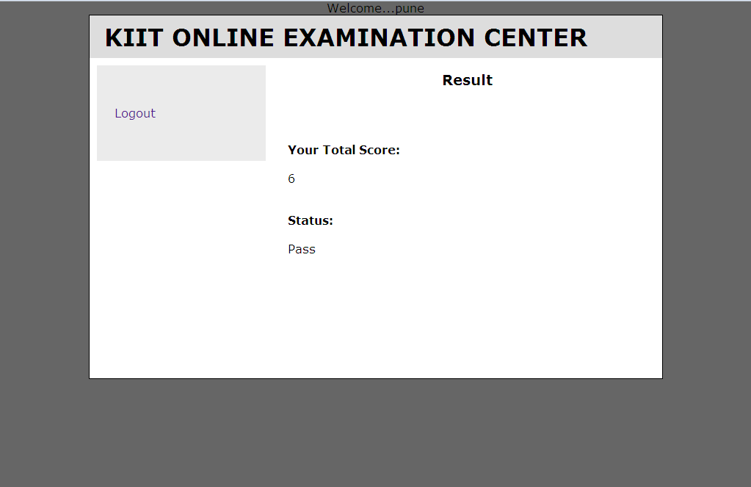

Fig: Result Page

Code Snippets:

Function to check log in details from database:

<?php session_start(); ?>
<?php
$host="localhost"; // Host name
$username="root"; // Mysql username
$password=""; // Mysql password
$db_name="online_exam"; // Database name
$tbl_name="admin"; // Table name

// Connect to server and select databse.
mysql_connect("$host", "$username", "$password")or die("cannot connect");
mysql_select_db("$db_name")or die("cannot select DB");

// username and password sent from here
$myusername=$_POST['id'];
$mypassword=$_POST['pass'];

$sql="select * from $tbl_name where name='$myusername' and password='$mypassword'";
$result=mysql_query($sql);
$count=mysql_num_rows($result);
// If result matched $myusername and $mypassword, table row must be 1 row

if($count==1)
{
// store session data
$row = mysql_fetch_array($result);
$_SESSION['admin_id']= $row['admin_id'] ;
header("location:registerstudent.php");
}
else
{
header("location:adminlogin.php");
}
?>

Function to upload question into database:
<?php
$fqid=$_POST["question_id"];
$fques=$_POST["question"];
$fans1=$_POST["answer1"];
$fans2=$_POST["answer2"];
$fans3=$_POST["answer3"];
$fans4=$_POST["answer4"];
$fcoption=$_POST["correct_option"];

$con = mysql_connect("localhost","root","");
if (!$con) { die('Could not connect: ' . mysql_error()); }

mysql_select_db("online_exam", $con);

mysql_query("insert into question(`question_id`,`question`,`answer1`, `answer2`, `answer3`,`answer4`,`correct_option`) values ('$fqid','$fques','$fans1','$fans2', '$fans3','$fans4','$fcoption') ");

//Retrieving data from dtabases
$result = mysql_query("select * from question");
echo "<table border='1'>
<tr>
<th>Q.ID</th><th>Ques</th><th>Ans1</th><th>Ans2</th>
<th>Ans3</th><th>Ans4</th><th>Coption</th></tr>";

while($row = mysql_fetch_array($result)) {
echo "<tr>";
echo "<td>" . $row['question_id'] . "</td>";
echo "<td>" . $row['question'] . "</td>";
echo "<td>" . $row['answer1'] . "</td>";
echo "<td>" . $row['answer2'] . "</td>";
echo "<td>" . $row['answer3'] . "</td>";
echo "<td>" . $row['answer4'] . "</td>";
echo "<td>" . $row['correct_option'] . "</td>";
echo "</tr>";
}
echo "</table>";
mysql_close($con);
echo "<br/>";echo "<br/>";echo "<br/>";echo "<br/>";
echo "Question has successfully uploaded in the server";

?>

Testing:

In testing phase, various type of testing are used-
1. Unit testing: - unit test is method of testing that verifies the individual units of source code working properly. A unit is smallest testable part of an application. Test cases are generated in Unit testing. Each test case is independent from others.

2. Integrated testing: - In integrated testing each individual software module are combined and tested as a group. Integration testing takes as it input module that has been unit tested, group them in larger aggregates, applies test defined in an integration test plan to those aggregates and delivers as its output the integrated system ready for system testing.

3. System testing: - System testing is performed on the entire system to assure to meet the requirement. There are mainly two types of system testing
Alpha Testing: Alpha testing refers to system testing carried out by test team.
Beta Testing: Beta testing is the system testing performed by a select group of friendly customer.

Test Suit:
1. User Login (UL) Test case:
Input of UL test case:
username and password
username and password is checked from database

If (username and password is valid)
Then output is welcome “username”
Else
Invalid username and password
2. Register Student Test case:
Input of test case:
Student Details

If (all details are valid)
Then output is system generated password
Else
Invalid student details
3.Enter exam password Test case:
Input of test case:
Exam password
Password is checked from database

If (password is valid)
Then output is exam start page
Else
Invalid password

Future Scope:

Scope of this project is very broad in terms of other manually taking exams.
Few of them are:-

>This can be used in educational institutions as well as in corporate
world.

>Can be used anywhere any time as it is a web based application(user
location doesn’t matter).

>No restriction that examiner has to be present when the candidate
takes the test.

Conclusion:

We hope that our project on “ONLINE EXAMINATION SYSTEM” would be beneficial for both the students and teachers and can solve the problems of Manual Examination Procedure .

It saves time as it allows number of students to give the exam at a time
and displays the results as the test gets over, so no need to wait for the result.
It is automatically generated by the server. Administrator has a privilege to create, modify and delete the test papers and its particular questions. User can login and give the test with his specific id, and can see the results as well.

Bibliography:

1.Introduction to Software Engineering by Rajib Mall
We have read this book and from this book we have learned a lot of valuable information such as Requirements Analysis and specification and also we have followed the format of functional requirement from this book.

2.www.testfunda.com
We have searched every page of freshers.com and analyzed it .From this we have also learned a lot of valuable information for this project.

3.www.ieee.org
We have seen SRS template of ieee and we have got idea of making good and efficient SRS.

